To solve the program there is two way, first one we will use an array and the second one just use a variable :

The link for the first program is:

<http://tpcg.io/FHfyfRao>

before execute the program insert this line for input as follow :

1-click on STDN

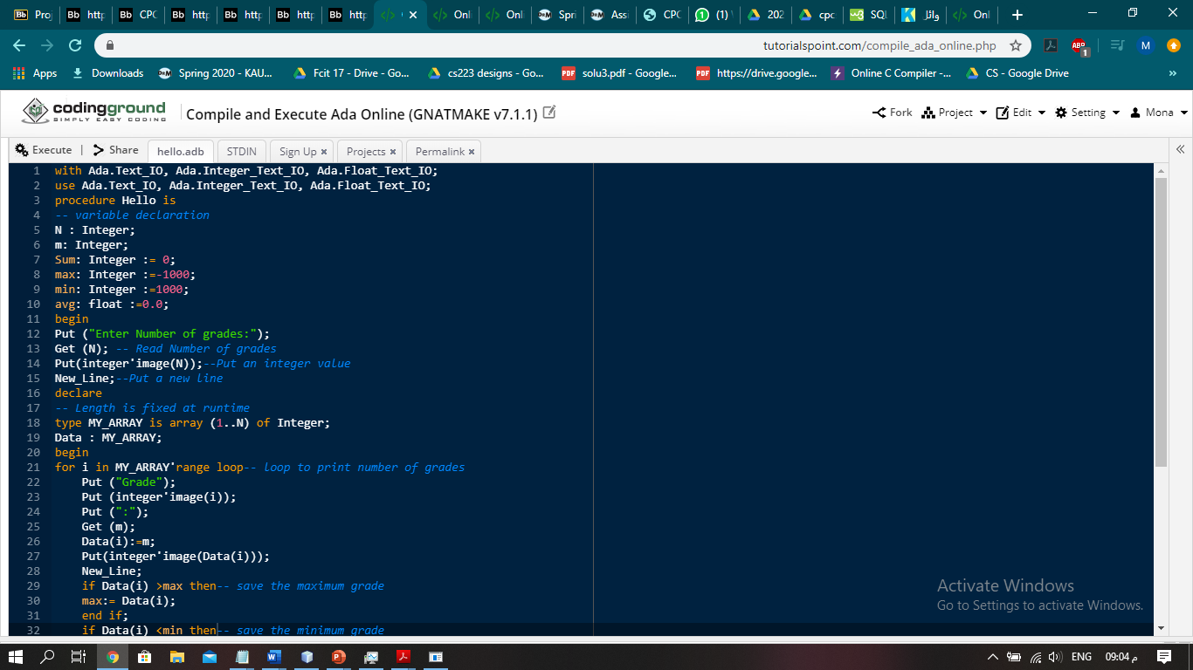

2-insert this line as follow:

4 24 12 33 17

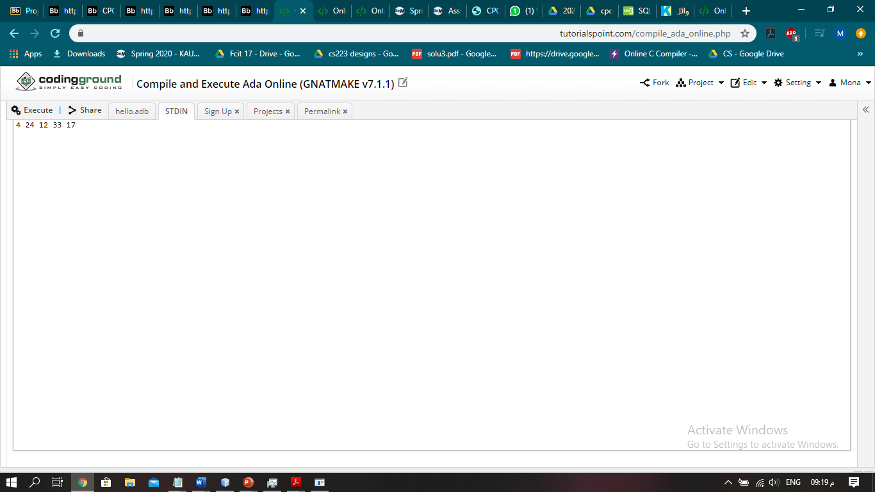

3- execute the programme

First code:

|  |
| --- |
| with Ada.Text_IO, Ada.Integer_Text_IO, Ada.Float_Text_IO;  use Ada.Text_IO, Ada.Integer_Text_IO, Ada.Float_Text_IO;  procedure Hello is  -- variable declaration  N : Integer;  m: Integer;  Sum: Integer := 0;  max: Integer :=-1000;  min: Integer :=1000;  avg: float :=0.0;  begin  Put ("Enter Number of grades:");  Get (N); -- Read Number of grades  Put(integer'image(N));--Put an integer value  New_Line;--Put a new line  declare  -- Length is fixed at runtime  type MY_ARRAY is array (1..N) of Integer;  Data : MY_ARRAY;  begin  for i in MY_ARRAY'range loop-- loop to print number of grades  Put ("Grade");  Put (integer'image(i));  Put (":");  Get (m);  Data(i):=m;  Put(integer'image(Data(i)));  New_Line;  if Data(i) >max then-- save the maximum grade  max:= Data(i);  end if;  if Data(i) <min then-- save the minimum grade  min:= Data(i);  end if;  Sum := Sum + Data(i);-- sum of all grades  end loop;  New_Line ;  Put ("Average:");  avg:=Float(Sum) / Float(N);-- calculat the average  Put (avg, Fore => 4, Aft => 1, Exp => 0);--put the result of the average using this formatt  New_Line;  Put ("Maximum Grade:");  Put (integer'image(max));--put the max grade  New_Line;  Put ("Minimum Grade:");  Put (integer'image(min));--put the min grade  New_Line;  end;  end Hello; |

The output:

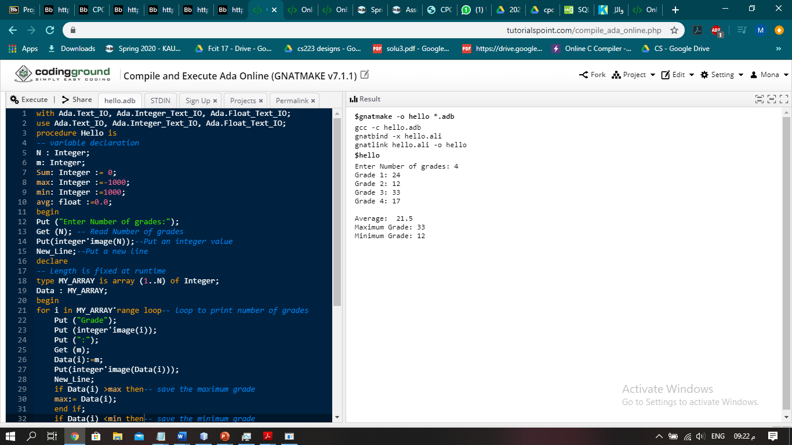

The link for the second program is:

<http://tpcg.io/SVsfIw7O>

before execute the program please follow this steps :

1-click on STDN



2-insert this line as follow:

4 24 12 33 17



3- execute the programme

Second code:

|  |
| --- |
| with Ada.Text_IO, Ada.Integer_Text_IO, Ada.Float_Text_IO;  use Ada.Text_IO, Ada.Integer_Text_IO, Ada.Float_Text_IO;  procedure Hello is  -- variable declaration  N: Integer;  m: Integer;  Sum: Integer := 0;  max: Integer :=-1000;  min: Integer :=1000;  avg: float :=0.0;  begin  Put("Enter Number of grades:");  Get(N);-- Read Number of grades  Put(integer'image(N));--Put an integer value  New_Line; --Put a new line  for I in 1..N loop-- loop to print number of grades  Put ("Grade");  Put (integer'image(i));  Put (":");  Get (m);  Put(integer'image(m));  New_Line;  if m >max then-- save the maximum grade  max:= m;  end if;  if m <min then-- save the minimum grade  min:= m;  end if;  Sum := Sum + m;-- sum of all grades  end loop;  New_Line;  Put ("Average:");  avg:=Float(Sum) / Float(N);-- calculat the average  Put (avg, Fore => 4, Aft => 1, Exp => 0);--put the result of the average using this formatt  New_Line;  Put ("Maximum Grade:");  Put (integer'image(max));--put the max grade  New_Line;  Put ("Minimum Grade:");  Put (integer'image(min));--put the min grade  New_Line;  end Hello; |

The output:

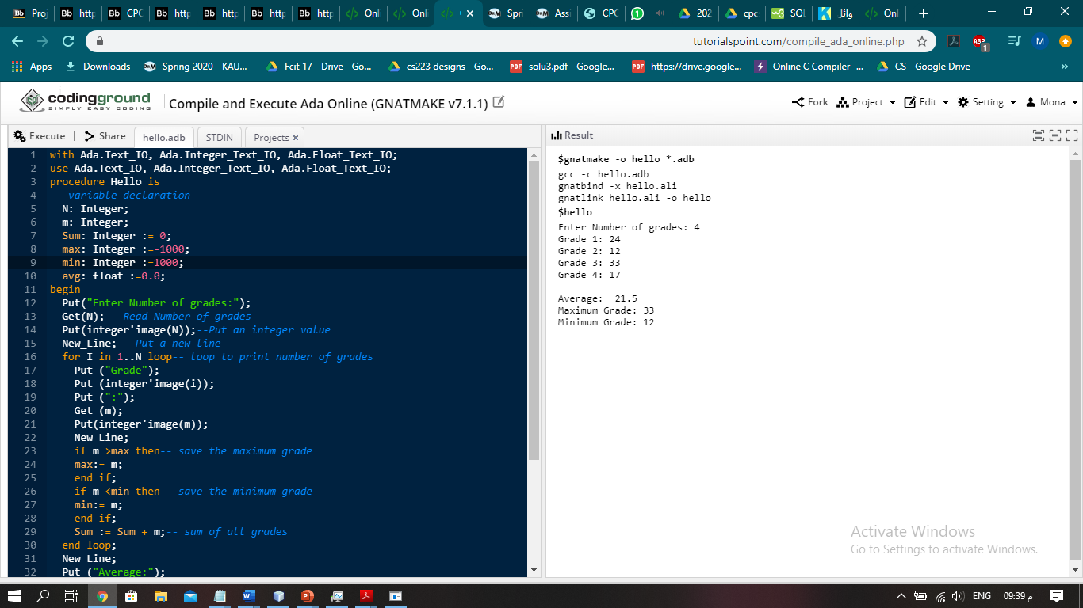

We use the following online compiler for Ada : <https://www.tutorialspoint.com/compile_ada_online.php>